**Current Opinion in Neuroscience Review Literature Search March 2021**

*Kelly Wallace & Hans Hofmann*

*\*SN, CE, AC, and SNCE searches were conducted on March 4th, 2021. SNAC was conducted March 9th, 2021.*

**We performed searches both in PubMed and Google Scholar, and chose to use PubMed for the rest of the analyses for two primary reasons:**

Google Scholar returned a large number of results, which raised concerns about specificity

* + “social neuroscience animal” returned about 1.9 million results
  + “animal cognition” returned about 2.7 million results
  + “cognitive ecology animal” returned about 750,000 results

We cannot directly export the search results from Google Scholar without third-party software

**The three PubMed searches searched “all fields”, e.g. the search term was not limited to matches within the title or abstract** (the results were like <50 if restricted)

(social neuroscience) AND (animal): 19,669 results (any year including 2021)

(cognitive ecology) AND (animal): 1,068 results (any year including 2021)

(animal cognition): 17,833 results (any year including 2021)

We acknowledge that cognitive ecology is *more* underrepresented relative to the other searches in PubMed than Google Scholar, though both search engines show a similar pattern.

**To understand the timeline of where these two fields are overlapping, we conducted two additional PubMed searches: SNCE and SNAC**

(**social neuroscience**) AND (**cognitive ecology**) AND (**animal**): 113 results (all years including 2021). The earliest hit for this search was 2001, and the first year with over 10 results was 2014, suggesting this “explicit” overlap is a relatively new development.

(**social neuroscience**) AND (**animal cognition**): 2,564 results (all years including 2021). The earliest hit for this search was 1989, and the first year with over 10 results was 2000.

**To better understand popular search terms, we subsetted to within the past 5 years (excluding 2021, so those published in 2016-2020)**

(**social neuroscience**) AND (animal): 9,323 results (2016-2020) spanning 1,093 journals (or other publishers like book chapters). The three most popular journals in the SN search were *J Neurosci, Sci Rep,* and *Neuroscience*

(**cognitive ecology**) AND (animal): 635 results (2016-2020) spanning 178 journals. The three most popular journals in the CE search were *Proc Biol Sci*, *Anim Cogn*, and *Sci Rep*

(**animal cognition**): 6,676 results (2016-2020) spanning 1187 journals. The three most popular journals in the AC search were Behav *Brain Res,* *Sci Rep,* and *Anim Cogn*

(**social neuroscience**) AND (**cognitive ecology**) AND (animal): 85 results (2016-2020) spanning 54 journals. The three most popular journals in the SNCE search were *Sci Adv*, *Philos Trans R Soc Lond B Biol Sci*, and *Proc Biol Sci.*

(**social neuroscience**) AND (**animal cognition**): 1299 results (2016-2020) spanning 375 journals. The three most popular journals in the SNAC search were *Anim Cogn, Neuroscience, and Behav Brain Res.*

Note: I’m also subsetting 2016-2020 for logistical reasons – you can’t export the full search csv if there are over 10k entries (you can export the “publications per year” metadata over 10k, but not the individual results).

Interestingly, the cognitive ecology search is *much* smaller than the other two, suggesting this field is not using specific language, and is rather still part of the larger “animal cognition” (which can also be seen in the overlap in their three most popular journals. Unsurprisingly, cognitive ecology overlaps more with animal cognition (39.5% of CE pubs are also found in the AC pubs) more than social neuroscience (13.4% of CE pubs are also found in the SN pubs). This suggests that cognitive ecology stems from but is still distinct from animal cognition more broadly. From here we further explore the small (13%) overlap between cognitive ecology and social neuroscience.

**(fig will not actually be included, but we can reference these results in the text)** Most frequent title words in each search (unsure if we’ll use this one or not!). Animal cognition (AC), social neuroscience (SN), and the intersect (SNAC) are rodent-biased. This is not seen in cognitive ecology (CE), suggesting that cognitive ecology encompasses a variety of systems and is distinct from animal cognition more broadly.

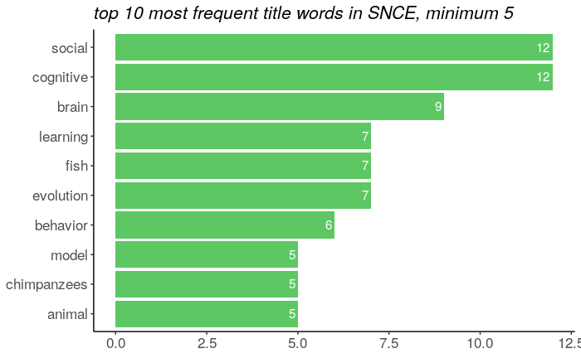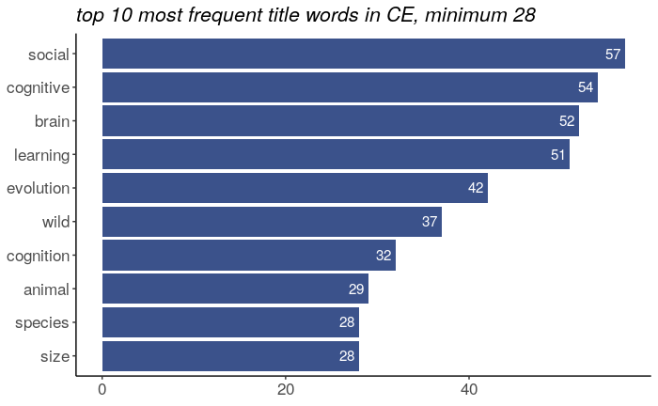Furthermore we see that a variety of model systems is prioritized in the intersection of social neuroscience and cognition (SNCE has both fish and chimpanzees). Also of note is “wild” in cognitive ecology, and “social” in cognitive ecology (interesting that social is #1 in the CE search even though it was not a term in the search itself!)

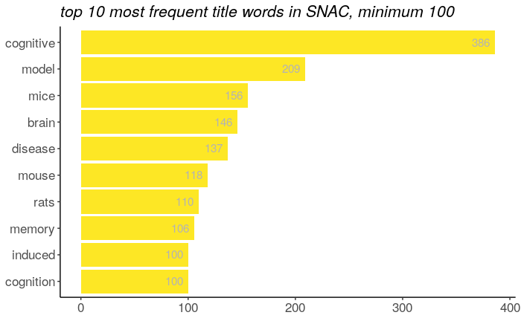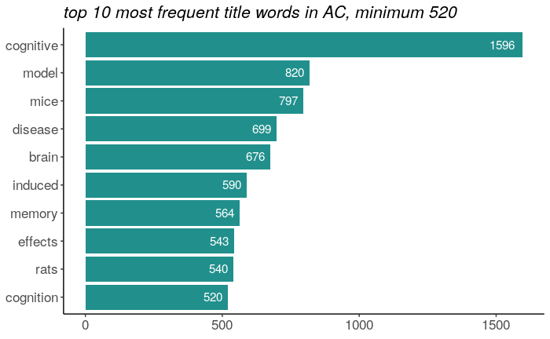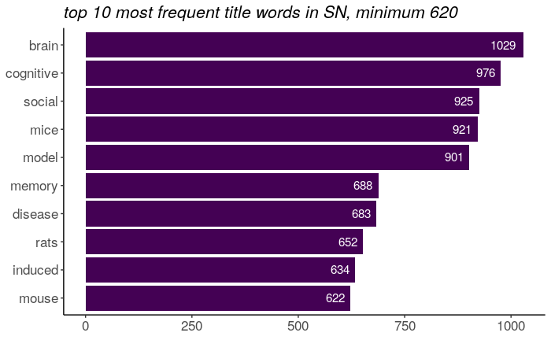

**Fig1A.** Plotting the trajectory of each field (publications in a given year). This is not scaled, which allows us to see the difference in overall size of each field.1963-2019 (because of COVID drop off in 2020)

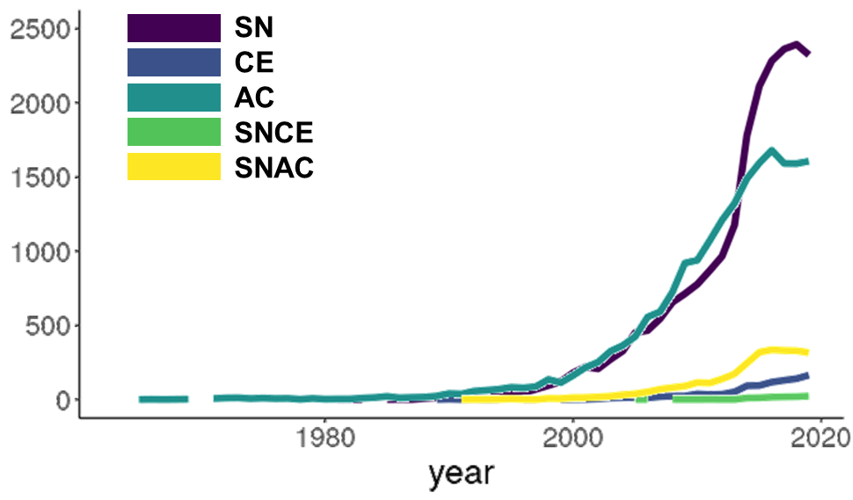

**Fig1B.** Same dataset, but now each field is scaled from 0 to 1, where 1 is the maximum number of publications found in any year (for example, the most publications in a year for SN was 2018 with 2393 publications, so every other year is scaled to X pubs in that year / 2393). This scaling allows us to better see the difference in timing when each field started gaining momentum to its current state. Animal cognition is the oldest field of them all according to our search, but explicit emphasis on ecology (CE) is newer, and even more so the explicit overlap between SN and CE (SNCE) really has only been since ~2013. I’m only showing 1995-2020 because before 1995 it’s basically a flat line (which you can see in the top graph), and removing pre 1995 allows you to see the differences once the fields all started publishing easier than them all being squished on the right side of the graph.

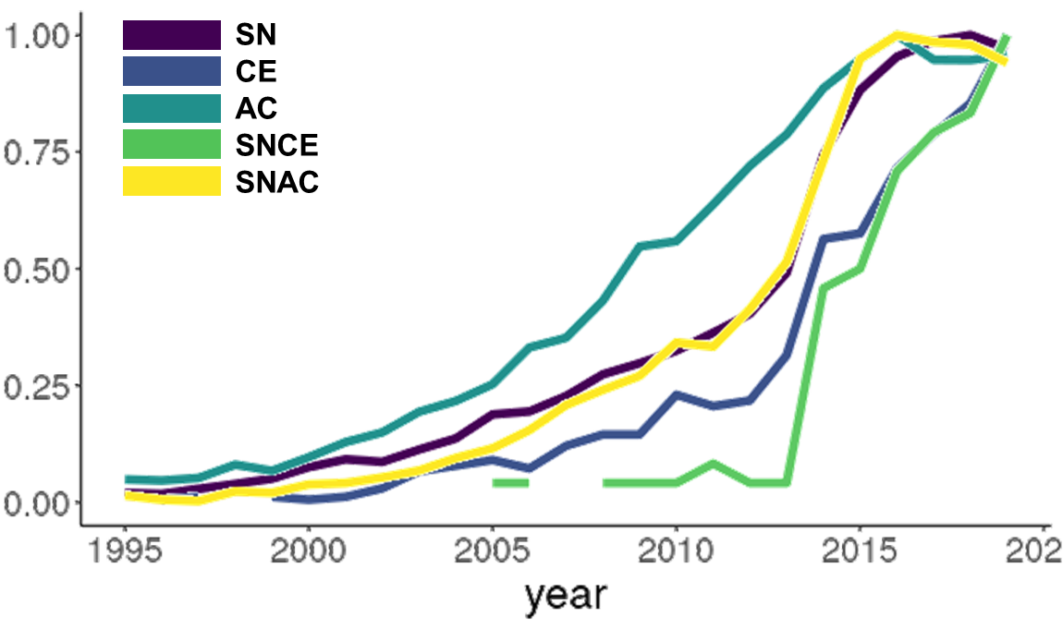

**Below are the old figures not including SNAC:**

**Fig1A.** Plotting the trajectory of each field (publications in a given year). This is not scaled, which allows us to see the difference in overall size of each field.1963-2019

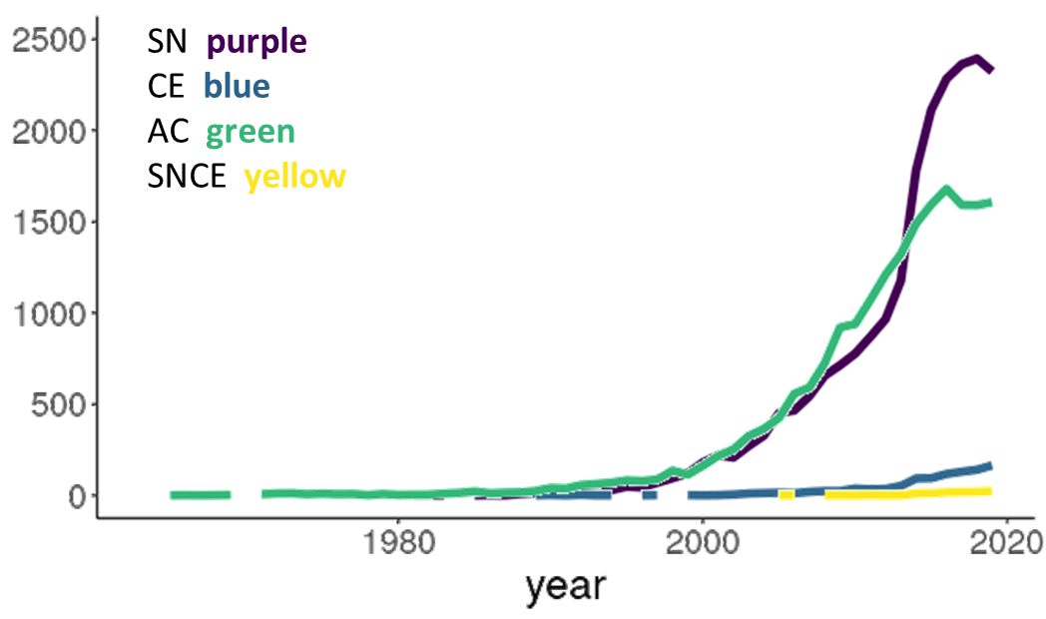

**Fig1B.** Same dataset, but now each field is scaled from 0 to 1, where 1 is the maximum number of publications found in any year (for example, the most publications in a year for SN was 2018 with 2393 publications, so every other year is scaled to X pubs in that year / 2393). This scaling allows us to better see the difference in timing when each field started gaining momentum to its current state. Animal cognition is the oldest field of them all according to our search, but explicit emphasis on ecology (CE) is newer, and even more so the explicit overlap between SN and CE (SNCE) really has only been since ~2013

